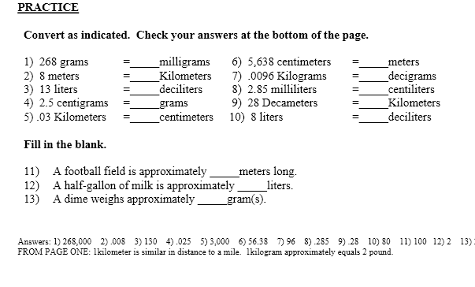
- 7 cm = ______ mm
b) 32 m = ______ cm
c) 58 km = ______ m
d) 75 km = ______ cm
e) 65 000 cm = ______ km
f) 56 m = ______ km

- 70, b) 3200 c) 58000 d) 750000 e) 65 f) 0.056

State whether you think each measurement is reported in the most appropriate unit. If not, explain why and convert it to a more appropriate SI unit.

a) The length of a housefly is 0.005 m.
b) The depth of the Pacific Ocean is
4 188 000 mm.
c) The length of a table-tennis table is
0.002 74 km.
d) The height of the CN Tower in Toronto, Ontario, is 55 300 cm.

- No 5 mm b) No 4.188 km c) No 2.74 m d) No 553.00 m

